# Dashboard Sample Application

The Dashboard is a powerful sample application that allows you track vehicle positions on a map, receive status updates relating to Stops/Orders, and monitor pre-defined alerts associated with each route.

# Installation

1. Download the ZIP file
2. Unzip the contents to your webserver root directory
   1. [IIS], unzip to “c:\inetpub\wwwroot”
3. The unzip process will put an application folder, “tasa”, at your webserver root
   1. [IIS] “c:\inetpub\wwwroot\tasa\”
4. [Windows] Verify that both folders are not encrypted
   1. Right click on each folder and go to Properties -> Advanced and **uncheck** the “Encrypt contents to secure data”
   2. Click OK to dismiss the dialogs and confirm all attribute changes to the folder, subfolder and files
5. The unzip process will also place the necessary proxy files needed for the Dashboard application
   1. [IIS] “proxy.ashx” & “proxy.config”
   2. [PHP] For PHP setup, please reference the Esri JavaScript API Resource Center, Working with ArcGIS Server Services, Using the Proxy Page

# Configuration

1. Configure the proxy page for use according to your webserver environment
   1. [IIS]
      1. Open “proxy.config” in a text editor
      2. Add a “serverUrl” XML node that will reference your instance of ArcGIS Server that contains your Workforce Management services

<serverUrl url=”http://localhost/arcgis/rest/services” matchAll=”true” />

* 1. Open “tasa/config.js” in a text editor
     1. Change the “Host” parameter to the machine name of the ArcGIS Server hosting the Workforce Management services
     2. Verify the references to the **layer indices** are correct so that each **layer index** points to the correct REST endpoint of your ArcGIS Server hosting the Workforce Management services
     3. [Optional. See Note #1 Below] Locate the “deviceIDs” key and enter in the Mobile Device ID(s) you wish to track
        1. Multiple IDs can be specified separated by commas. Ex. “[1234, 5678]”
     4. Refer to the comments in config.js to make any additional changes

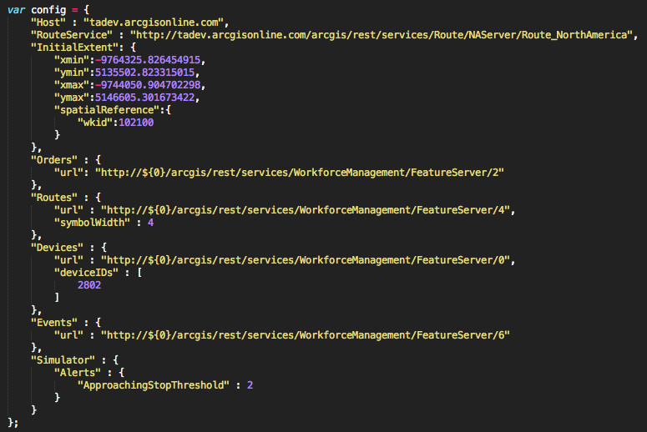

* 1. Open “tasa/app.js”
     1. Locate the line of code (usually around Line #30) that references the proxy.ashx page and verify it is pointing to your local proxy page
        1. [IIS] esri.config.defaults.proxyUrl = ../proxy.ashx

1. The Dashboard application can be loaded in a web browser
   1. [IIS] http://localhost/tasa/dashboard.html

# Notes

1. The “tasa/index.html” page is included as a quick way to load multiple routes and simulate their movement using an In-App Simulator. This is an optional step that eases the loading of specific routes by reading directly from the Workforce Management services to retrieve work for mobile devices

# Developer Tools & Resources

1. ArcGIS API for JavaScript
   1. Resource Center Home Page
      1. <http://help.arcgis.com/en/webapi/javascript/arcgis/>
2. Dojo
   1. AMD & Modules
      1. <http://dojotoolkit.org/documentation/tutorials/1.7/modules/>
   2. Using Custom Modules w/ a CDN
      1. <http://dojotoolkit.org/documentation/tutorials/1.7/cdn/>
3. Dojo dGrid (in beta as of 6/12/12)
   1. Home Page
      1. <http://dojofoundation.org/packages/dgrid/>
   2. Project page
      1. <http://github.com/SitePen/dgrid>
   3. Samples
      1. <http://sitepen.github.com/dgrid/dgrid/test/>
   4. SitePen Blog Post
      1. <http://www.sitepen.com/blog/2012/04/24/dgrid-getting-down-to-the-nitty-griddy/>
   5. Setup and Configuration
      1. [http://github.com/SitePen/dgrid#automatic-download-with-cpm](https://github.com/SitePen/dgrid#automatic-download-with-cpm)
   6. Inline JavaScript Manual Setup
      1. <http://github.com/SitePen/dgrid#manual-download>